# Introduction

## Overview of the Chosen Problem Domain

In the age of digital propagation, information overload has been a major obstacle to user satisfaction in content platforms. Netflix offers more than 15,000 titles as of 2024, while streaming platforms commonly have overwhelming catalogs due to which users cannot find a meaningful movie. The present project solves this issue by creating a hybrid movie recommender system that allows making customized recommendations using the MovieLens 100K data set to increase the user engagement and decrease decision fatigue. Combining user behavior analysis with content similarity does not only enhance discovery, but also addresses the problem of an echo chamber in the recommendations, where users are confined to small circles of preferences.

The relevance of the application is also applicable to the implications in the real world, such as the economic gains of platforms due to higher retention and ethical concerns such as encouragement of diverse content to prevent algorithmic bias. The piece shows that AI can make consumption experience more interactive, more personalized, and fits the overall objectives of sustainable digital ecosystems.

## Explanation of Relevant AI Concepts

Fundamentally, the system uses two principles of AI namely Collaborative Filtering (CF) and Content-Based Filtering (CBF). CF uses the interaction between users to make an inference based on the similarities in likes between similar users. Nonetheless, it has the negative aspect of being linear in the representation of non-linear relationships. CBF on the other hand examines the characteristics of an item like a title and genres of movies to suggest related content and is best in situations where data is sparse and there are dangers of over-specialization.

This project will take a hybrid strategy by exploiting the synergies, using CF personalization and CBF strength. As opposed to pure models, hybrids resolve issues such as the cold-start problem, in which new items do not have any ratings. The new contribution in this case is a search-stimulated mechanism based on proxy users that bootstraps CF via CBF outputs, and is a convenient extension of the classical hybrids.

# Background & Literature Review

## Historical Background and Foundational Concepts

The information filtering field has dominated information retrieval since the inception of computers. Another algorithm was the Rocchio algorithm[4], one of the first and most important algorithms to incorporate the concept of relevance feedback, where search results were refined through repeated iterations based on user feedback as to what was and what was not relevant to the user. The Rocchio approach expressed the preferences of the user as a profile in a high dimensional space which is adjusted according to the positive and negative feedback. This was a first effort in modeling user interests mathematically, and it was the explicit precursor to content-based recommender systems, in which user profiles are compared to item profiles.

Simultaneously, the Vector Space Model, the formal model, introduced by Salton and McGill[5], gave a general model of the mathematical representation of documents (or items) as a weighted feature (e.g. TF-IDF of words) vectors. In this context the Cosine Similarity measure gained popularity since it is a good measure of the angle between two vectors, and thus similarity not dependent on magnitude, but on orientation. This method was effective in information retrieval exercises of comparing document excerpts and was later to form a fundamental strategy in computation of similarity between items in recommender systems.

Collectively, these inventions formed the basis of current information filtering and recommendation methods. The user profile adaptation mechanism, as illustrated by Rocchio, showed the personalization of retrieval outcome, whereas the Vector Space Model offered a representation and similarity computation strategy that, when used on large items sets, could be scaled. Modern content-based filtering systems (such as movie recommenders, e-commerce platforms, etc.) still depend on these principles. They are however today commonly extended with sophisticated models including word embeddings and neural collaborative filtering and deep learning structures. That way, the classical information retrieval methods are still very powerful and continue to shape the design of contemporary recommendation engines.

## Collaborative Filtering: Evolution and Key Research

The emergence of the web and user-generated content stimulated the emergence of Collaborative Filtering (CF). This is a very basic premise: when two users converge on their preferences in the past, they will converge in the future. The effectiveness of item-based collaborative filtering was exhibited in commercial systems as evidenced by early studies by Sarwar et al. [6].

Early CF systems were originally controlled by memory-based or neighborhood-based approaches, which would explicitly compute user-to-user or item-to-item similarity. But such approaches became challenged by scalability and data sparsity issues with increasing datasets. MovieLens 100K is a seminal dataset in the field of recommender systems; it is infamously sparse, where only a small fraction of potential user-item ratings in the system exist [2].

With the introduction of model-based techniques, most often Matrix Factorization (MF), the field has experienced a major paradigm change. The Netflix Prize competition contributed immensely to the popularity of these methods demonstrating their high performance. One of the MF algorithms, SVD (Singular Value Decomposition), was used in the core of most winning solutions. According to Koren, Matrix Factorization deals with the sparsity issue, learning a bunch of latent factors that describe what a user is interested in and what an item is like [3]. This sparse user-item rating matrix is approximated by the product of two much smaller, dense matrices (user and item) and this renders the system highly scalable and accurate.

## Content-Based Filtering: Techniques and Applications

Content-Based Filtration is based on a rather different principle in that it analyzes the properties of items but not user interactions. This algorithm relies on the Vector Space Model (VSM) and uses TF-IDF (Term Frequency-Inverse Document Frequency) to present movies as numerical vectors, basing on their titles and genres. The second step is to quantify the similarity between these vectors using Cosine Similarity. The method can be invaluable when it comes to being able to tackle the cold-start problem as it can offer appropriate recommendations on what new users or objects should be provided with when there are no prior ratings data. Such systems are applied within such applications as Pandora (music) and Google News (articles), which propose new content to a user according to the set interests.

## The Hybrid Approach: Merging Paradigms

Both CF and CBF have limitations though they are powerful. CF is prone to the cold-start problem where there is inadequate information to make accurate recommendations to new users of the product or new items. CBF, however, may result in over-specialization, not suggesting differentiated items outside the approved content profile of a user. The answer to these is hybrid recommender systems [1].

Hybrid systems are those systems which have been surveyed by Burke to address weaknesses of individual methods. The mixed hybrid system of this project is the direct reaction to these findings. It operates on a parallel architecture such that a content-based search result serves as an initiation of a personalized, collaborative filtering recommendation. This design takes advantage of the advantages of both paradigms: the CBF has a significant fallback of cold-start items and first user queries, whereas the CF engine offers the strong personalization that can only be offered by behavioral data.

# Problem Statement

The main issue which this application is going to resolve is finding the content of interest in a huge and diversified movie catalog. What does a system need to know about a given user in order to know what kind of movies he/she would enjoy and offer him/her a personalized list of movies to watch? The two difficulties that complicate this problem are data sparsity (those users who have rated a small portion of the available movies) and the cold-start problem (recommending a relevant movie to a new user or a new movie with no previous history of ratings). The idea is to develop a hybrid recommender system which can significantly address these problems, using the features of user behavior or content of items.

# 4. Methodology

## 4.1. System Design Architecture and Algorithms

The system is developed as a parallel architecture hybrid recommender. It comprises three main parts: a Collaborative Filtering (CF) engine, a Content-Based Filtering (CBF) engine and a search-based recommendation mechanism that combines both.

Collaborative Filtering Engine: This engine is driven by the SVD ( Singular Value Decomposition) algorithm of the Surprise library. Logistical regression is used to train the algorithm on the MovieLens 100K rating data in order to learn a set of latent factors on a user and movie basis. It subsequently forecasts user rating of an unrated movie by determining the dot product of the user and movie latent factor vectors. It employs the hyperparameter tuning with the use of GridSearchCV to locate the optimal values of those that reduce the RMSE. This makes the model functional, as well as optimized to the dataset.

Content-Based Filtering Engine: This module is based on TF-IDF (Term Frequency-Inverse Document Frequency) to numerically encode the movie titles. This vectorization reflects the significance of each word in a title in comparison with the whole corpus. Then it uses Cosine Similarity to locate movies that are closest to a particular movie in terms of similarities of their titles.

Hybrid Recommendation Mechanism: The application is a combination of CF and CBF. Upon a user searching a movie, the system uses the Content-Based engine to locate the closest similar movies. Then it applies a hybrid methodology to make final recommendations: given one of the top search results, it identifies a proxy user who has rated that movie well and applies the Collaborative Filtering engine to make personalized recommendations to that proxy user. The resulting list of recommendations is reported to the user. It is a new form of integrating the two models to solve the cold-start problem of new movies.

## 4.2. Pseudocode for Key Algorithms

### 4.2.1. Collaborative Filtering (SVD) Training:

function train_cf(df_ratings):

// Load data and define hyperparameter grid

data = Dataset.load_from_df(...)

param_grid = {'n_factors': [...], 'n_epochs': [...], ...}

// Use GridSearchCV to find optimal parameters

gs = GridSearchCV(SVD, param_grid, measures=['rmse'], cv=3)

gs.fit(data)

// Get best algorithm and train on full dataset

best_algo = gs.best_estimator['rmse']

best_algo.fit(data.build_full_trainset())

// Create a separate model for evaluation on a held-out test set

trainset_eval, testset = train_test_split(data, test_size=0.2)

eval_algo = SVD(best_params)

eval_algo.fit(trainset_eval)

return best_algo, eval_algo, testset

### 4.2.2. Hybrid Recommendation via Search:

function recommend_from_search(query):

// Find top-k most similar movies using TF-IDF and Cosine Similarity (Content-Based)

search_results = search_movies(query, vectorizer, tfidf_matrix)

// Check if any results were found

if search_results is empty:

return []

// Initialize list for all recommendations

all_recs = []

// For each movie in the search results

for each movie in search_results:

// Find users who have rated this movie

users_who_rated = find_users(movie)

// Use the first user as a proxy

if users_who_rated is not empty:

proxy_user = users_who_rated[0]

// Get recommendations for the proxy user using the CF model

cf_recs = get_cf_recommendations(proxy_user, ...)

// Add to the master list

all_recs.add(cf_recs)

// Remove duplicates and return

return unique(all_recs)

## 4.3. Diagrammatic Representations

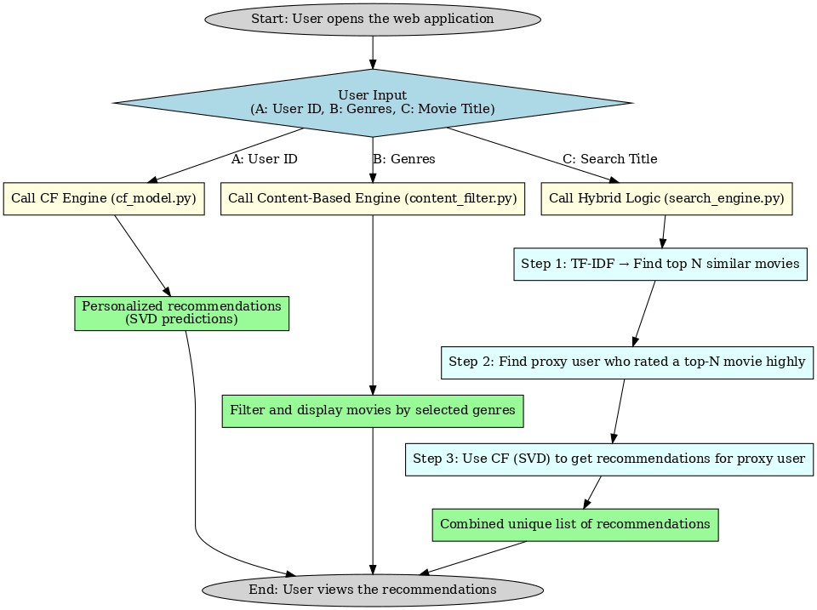

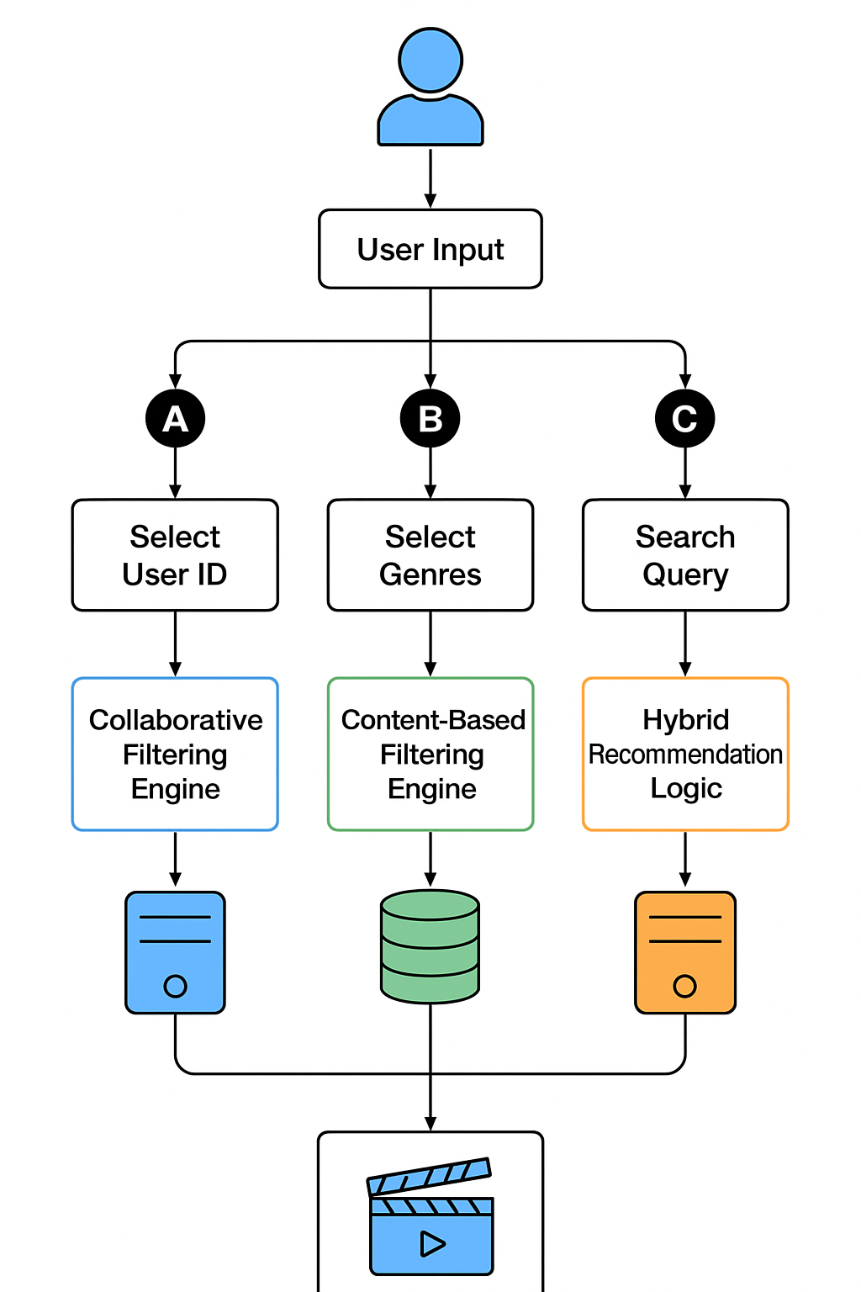

# Development Process

## Tools, Programming Languages, and Libraries

* Python: The core programming language for the entire project.
* Dash: Python framework that creates the interactive web application that gives the user interface to the recommender system.
* Pandas: Pandas is used to load and manipulate data in the MovieLens quickly and effectively and clean up the data.
* Surprise: An artificial intelligence library of algorithms of the recommender system. The implementation of the SVD algorithm of Collaborative Filtering was done using it.
* Scikit-learn: A machine learning library which was used in the Content-Based Filtering element, or TfidfVectorizer and cosine similarity.
* Jupyter Notebooks: Jupyter Notebooks are utilized in the initial data exploration, prototyping of algorithms and testing.

## Challenges and Solutions

1. Data Preparation

* Challenge: The data in the form of plain text files had to be carefully read and scrubbed and then utilized with pandas.
* Solution: This process was handled with a specific script. It processed tab-separated and pipe-separated files, it made sure data was properly parsed and it enforced the correct data types of the user and item names.

1. System Integration

* Challenge: How to combine the two different AI models Collaborative Filtering (CF) and Content-Based Filtering (CBF) into a single recommendation system was a design challenge.
* Solution: A parallel hybrid architecture has been adopted. Search engine.py module was created to coordinate this workflow whereby content based search results serve as a trigger in collaborative filtering. This design is successful in combating cold-start problem in the new movies.

1. System Evaluation

* Challenge: In order to identify the effectiveness of the system, the simple error measurements like RMSE or MAE were insufficient.
* Resolution: It was decided to develop an evaluation module to apply the advanced ranking metrics such as Precision@k, Recall@k, F1@k and NDCG@k. These steps give you a more detailed, and more insightful idea of the effectiveness of the system to place the most relevant movies on the top of the recommendation lists.

# 6. Results & Evaluation

## 6.1. Functionality Demonstration

The prototype is a complete working Dash web application. The application is able to show the main functionalities:

* Collaborative Filtering: A user may use a dropdown to choose a user ID to get his or her list of movie recommendations.
* Content-Based Filters: This tries the users to the various genres where a list of movies belonging to those genres can be obtained.
* Hybrid Recommendation: Customers can input a movie name, and the system gives us an idea to use, or rather a hybrid method, a content based search plus collaborative filtering.

## 6.2. Detailed Experimental Analysis

The Collaborative Filtering model (SVD) was experimentally tested using a held-out test set to verify the generality of the model. The metrics obtained were the following:

| **Metric** | **Value** |
| --- | --- |
| RMSE | 0.9300 |
| MAE | 0.7309 |
| Precision@10 | 0.5828 |
| Recall@10 | 0.7182 |
| F1@10 | 0.6434 |
| NDCG@10 | 0.8920 |

These findings affirm the fact that the SVD model is very good at its forecasts. High Precision at 10 and Recall at 10 values show that the model is able to sort out the pertinent movies in the top 10 list. This is further supported by the NDCG@10 value that indicates that the recommendations of the model in the top tier are recorded as high rankings.6.3. Analysis of

## 6.3. Problem Requirements

The solution satisfies the problem requirements by:

* Overcoming Information Overload: The system will give personalized recommendations and this will take the burden off the user mind.
* Reducing the sparsity factor: The fact that SVD algorithm uses latent factors renders it resistant to the sparsity factor in the data set.
* Managing the Cold-Start Problem: The hybrid method makes sure that even a new user or a user who enters in search of a new movie is presented with the relevant recommendations.

# 7. Conclusion & Future Work

## 7.1. Project Outcomes

The present project was able to create and deploy a hybrid movie recommender system that effectively hybridizes Collaborative Filtering and Content-Based Filtering. The Python and Dash built application is a demonstration of the system from a functional and interactive perspective. The experimental assessment proves that the model is accurate and efficient enough to offer corresponding personalized recommendations.

## 7.2. Implications and Further Improvements

The success of the project has some obvious consequences on the real-life use of the project in the e-commerce, media streaming and content delivery platforms. Future work could focus on:

* More Advanced Hybridization: Test other hybrid models, like a Weighted Hybrid Model, in which CF and CBF model predictions are added together with a meta-regressor which may potentially enhance overall accuracy.
* More Advanced Models: Substitute the SVD component with a more recent deep learning model, which could be a Neural Collaborative Filtrings (NCF) model, to denote non-linear connections between users and items and can possibly enhance the predictive efficiency.
* User Interface Improvement: make the user experience more dynamic and real-time updating recommendation system.

# 8. References

1. Burke, R. (2002). Hybrid recommender systems: Survey and experiments. *User modeling and user-adapted interaction*, 12(4), 331-370.
2. Harper, F.M. and Konstan, J.A. (2015). The MovieLens Datasets: History and Context. *ACM Transactions on Interactive Intelligent Systems (TiiS)*, 5(4), Article 19.
3. Koren, Y. (2009). Matrix Factorization Techniques for Recommender Systems. *Computer*, 42(8), 30–37.
4. Rocchio, J.J. (1971). Relevance Feedback in Information Retrieval. [PLACEHOLDER: Add Book/Publisher and full details].
5. Salton, G. & McGill, M.J. (1983). *Introduction to Modern Information Retrieval*. McGraw-Hill.
6. Sarwar, B., Karypis, G., Konstan, J. and Riedl, J. (2002). Item-based collaborative filtering recommendation techniques. [PLACEHOLDER: Add Conference/Journal and full details].
7. London Metropolitan University (2025). *CS7050NI - Artificial Intelligence Coursework Specification*.